**TRAINING MODULE**

**REQUEST FOR EXTERNAL TRAINING WORK FLOW**

**(Training Request for Employee)**

**EMPLOYEE** TO CREATE TRAINING REQUEST FORM AND SEND TO APPROVER FOR APPROVAL (SYSTEM WILL NOTIFY THE APPROVER ABOUT THE TRAINING REQUEST)

**APPROVER** TO APPROVE THE TRAINING REQUEST FORM AND SEND TO HR FOR VALIDATION AND SCHEDULE OF TRAINING (SYSTEM WILL NOTIFY HR FOR THE APPROVED TRAINING REQUEST)

**HR** TO INFORM THE EMPLOYEE REGARDING SCHEDULE OF TRAINING (SYSTEM WILL NOTIFY THE EMPLOYEE FOR THE SCHEDULE OF TRAINING)

**EMPLOYEE** TO ATTEND AND COMPLETE THE TRAINING

**HR** TO TAG ON THE TRAINING REQUEST FORM THAT THE EMPLOYE ATTENDED THE TRAINING

(SYSTEM WILL NOTIFY THE EMPLOYEE TO FILL-UP THE TRAINING EVALUATION FORM)

**EMPLOYEE** TO FILL-UP THE TRAINING EVALUATION FORM (SYSTEM WILL NOTIFY IMMEDIATE SUPERIOR/APPROVER AND HR ABOUT THE TRAINING EVALUATION SUBMITTED)

**INTERNAL/EXTERNAL TRAINING WORK FLOW**

**(Training Invitation from HR)**

**HR** TO CREATE TRAINING INVITATION TO EMPLOYEES (SYSTEM WILL NOTIFY ALL INVITED EMPLOYEE FOR CONFIRMATION)

**EMPLOYEE** TO CONFIRM WITH THE TRAINING SCHEDULE (SYSTEM WILL NOTIFY HR ABOUT THE CONFIRMATION

**EMPLOYEES** TO ATTEND AND COMPLETE THE TRAINING

**HR** TO CLOSE THE TRAINING INVITATION (SYSTEM WILL NOTIFY ALL CONFIRMED EMPLOYEES ABOUT THE SCHEDULE OF TRAINING)

**HR** TO TAG ON THE TRAINING REQUEST FORM THAT THE EMPLOYEE/S ATTENDED THE TRAINING (SYSTEM WILL NOTIFY THE EMPLOYEE TO FILL-UP THE TRAINING EVALUATION FORM)

**EMPLOYEES** TO FILL-UP THE TRAINING EVALUATION FORM (SYSTEM WILL NOTIFY IMMEDIATE SUPERIOR/APPROVER AND HR ABOUT THE TRAINING EVALUATION SUBMITTED)

1. **REQUEST FOR EXTERNAL TRAINING**

**A1.01 -** Employee will create request for external training

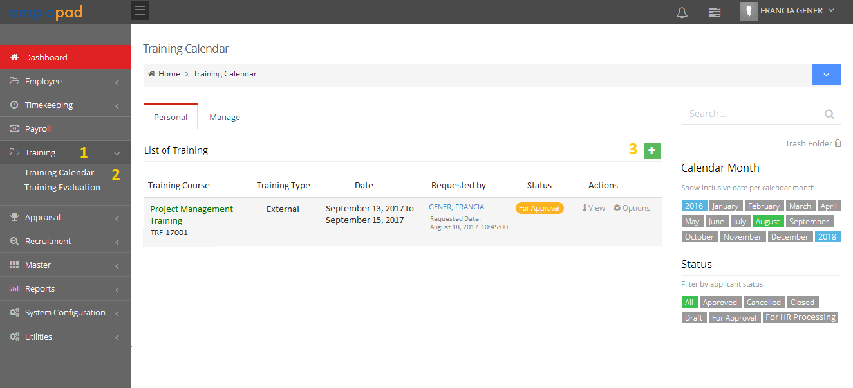

Personal Tab is for the personal training request

Manage Tab is for the approver of the training request

List of all training request of his/her subordinates

**A1.02 -** Training Request Form for fill-up by the employee.

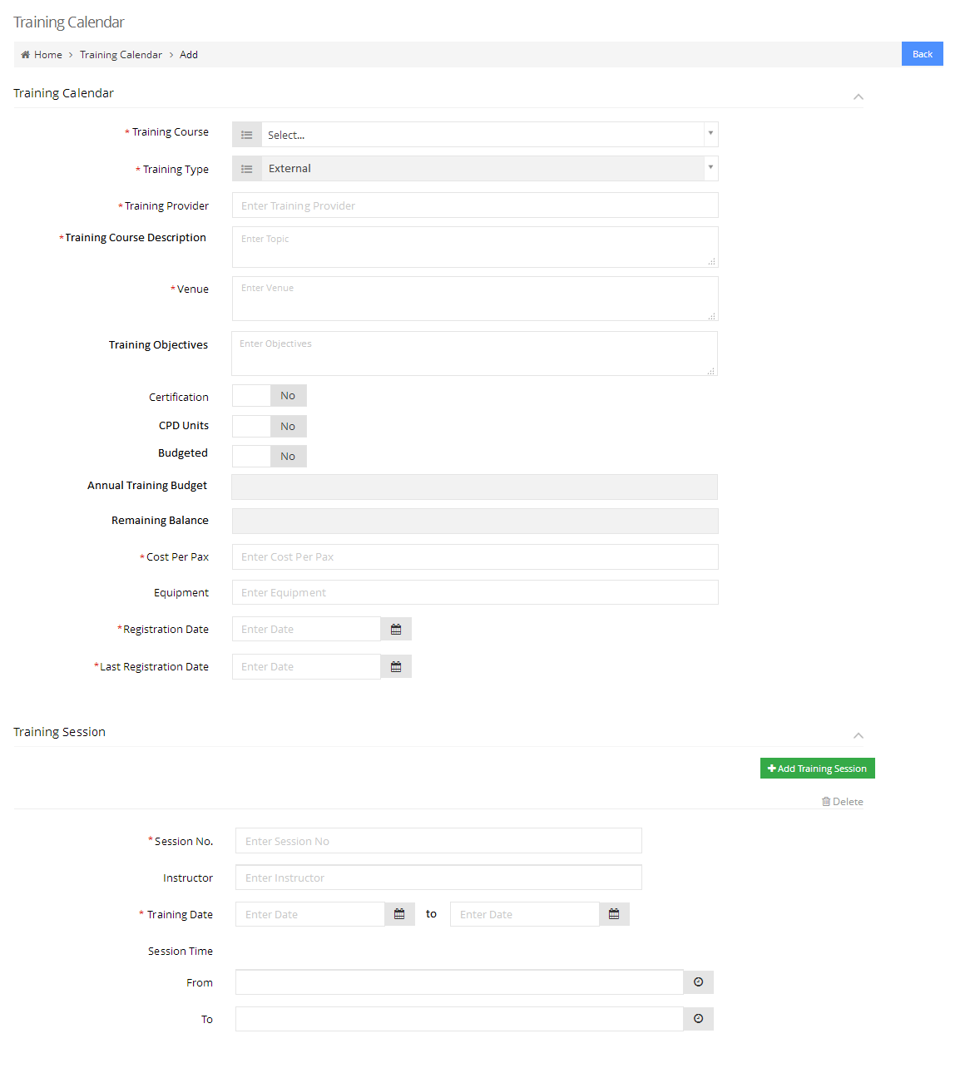

* List of all training courses from the master
* If training is not on the list, Employee must inform HR
* HR will add the training course on the master before employee create the request

Predefine per rank

Auto compute based on previous training attended

Option to breakdown details per session

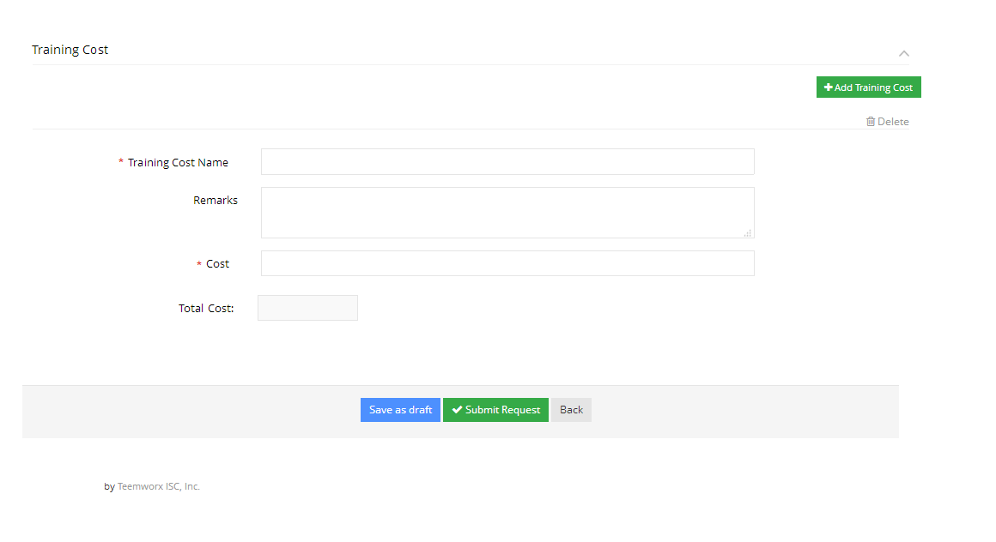

Option to breakdown details per training cost

Click *Submit Request* button to send the request to the approver.

*Note: System and email notification will be sent to approver*

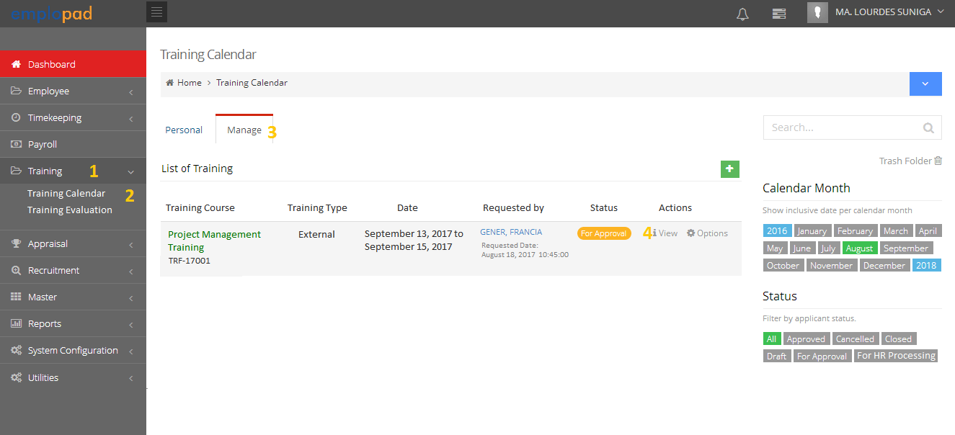**A1.03 –** Approver to review and approve the training request form

**A1.04 –** Training Request Form (Approver view)

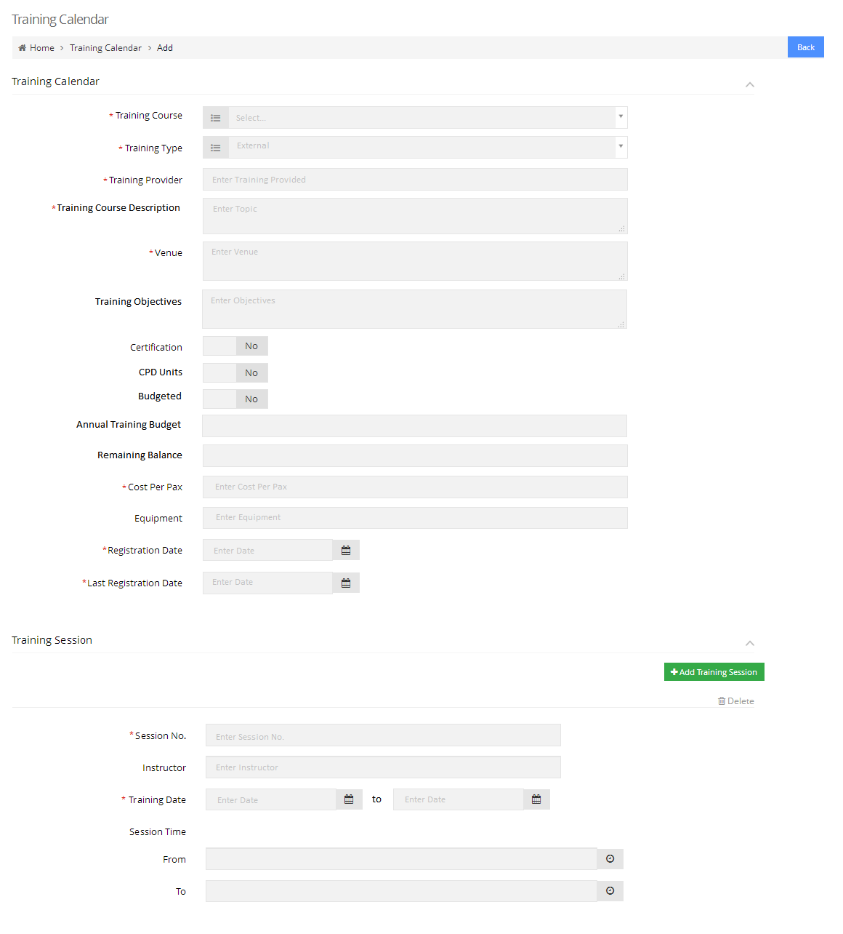

*Note: All fields are view only.*

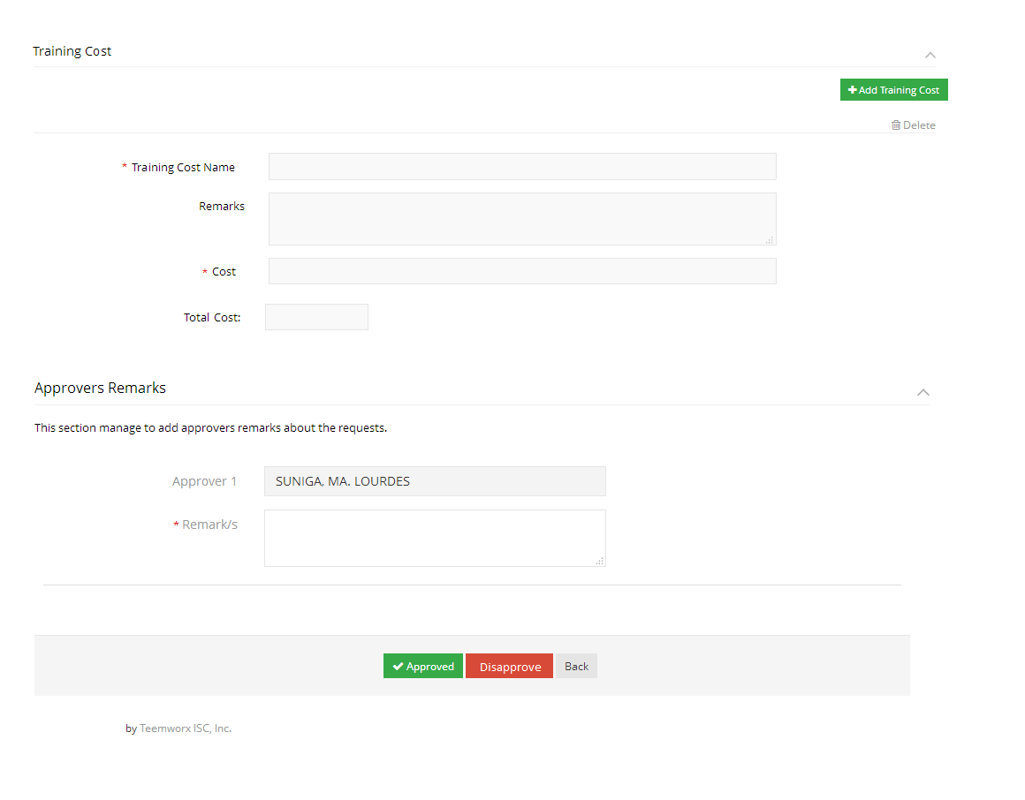

Add remarks then click *Approved* button to approve the request

*Note: System and email notification will be sent to HR for the processing of the training request*

**A1.05 –** Training Request (For HR Processing)

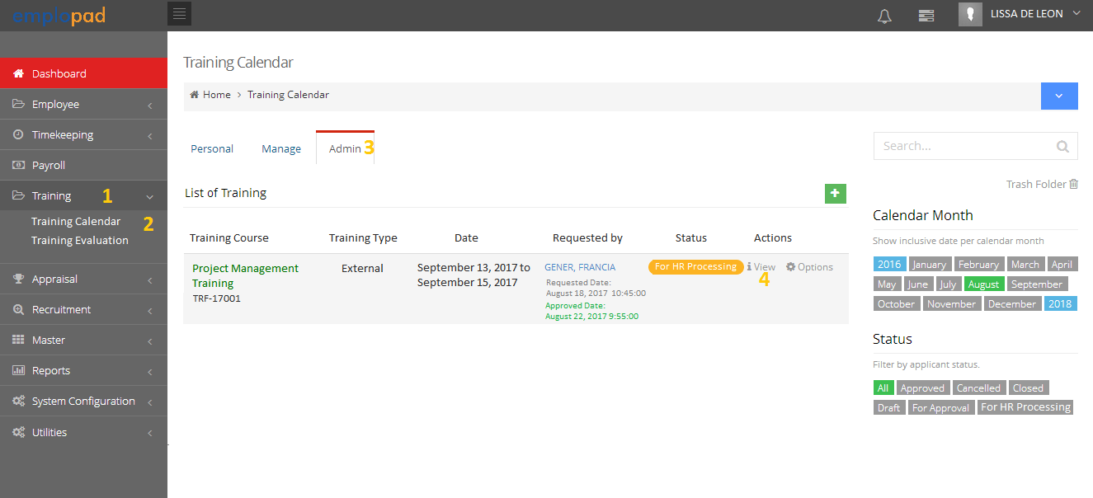

List of all employees training request

**A1.06 –** Training Request Form (HR View)



*Note: All fields are view only.*

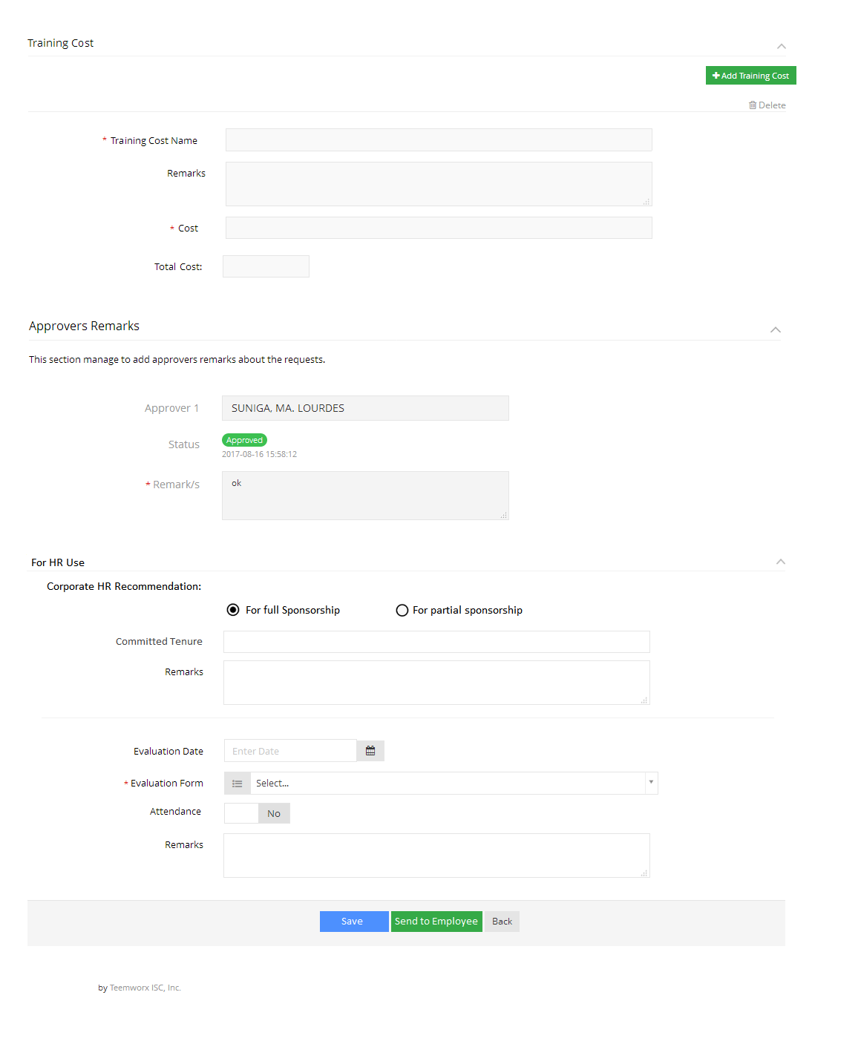

* External Training Report Form
* Feedback Form

Predefine base on policy

Click *Save* followed by *Send to Employee* button to complete the processing

*Note: System and email notification of approved training request will be sent to employee*

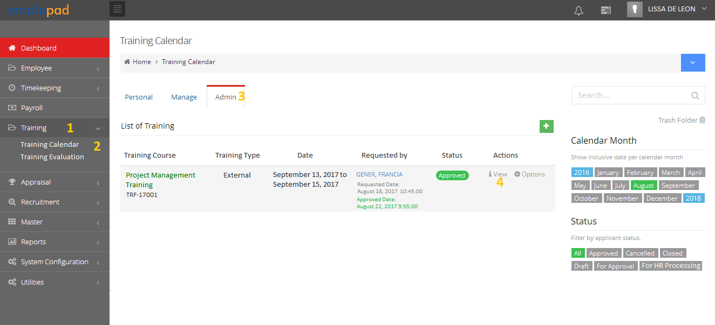**A1.07 –** Training Request Closing (HR)

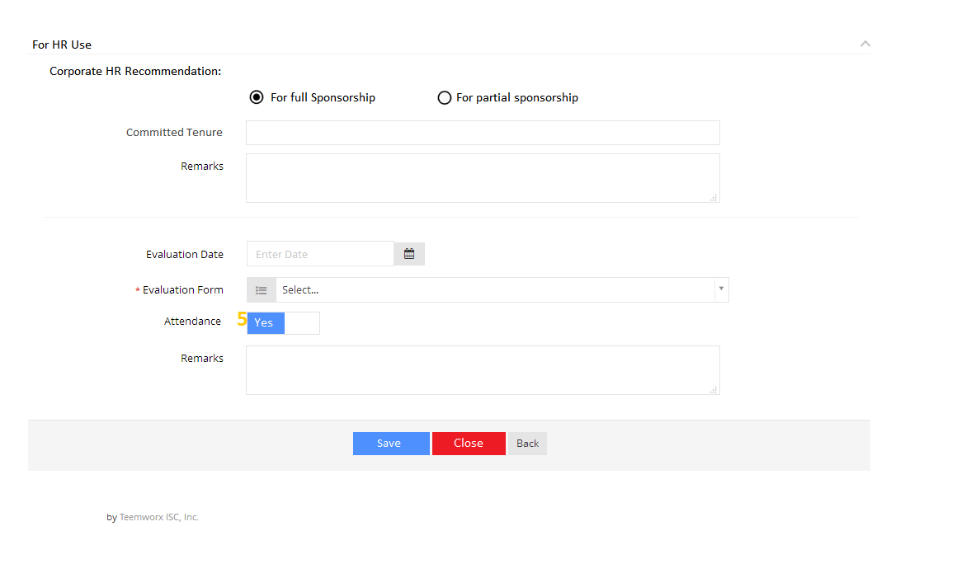**A1.08 –** Training Request Form (Closing)

Set Attendance to *Yes ,*click *Save* followed by *Close* button

*Note: System and email notification will be sent to the participant to accomplish the training evaluation form*

**A1.09 –** Training Evaluation

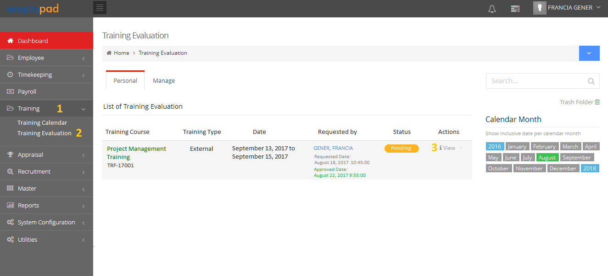

Personal Tab is for the personal training evaluation

List of all training evaluation of subordinates

**A1.10 –** Training Evaluation Form

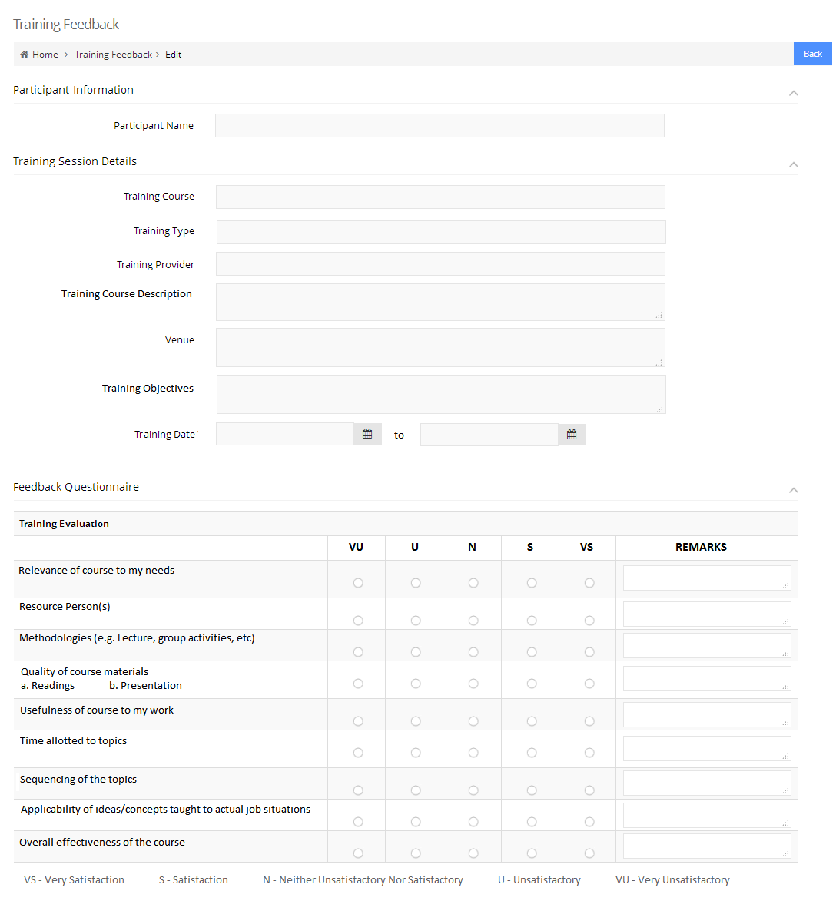

System to capture the information from the training request form

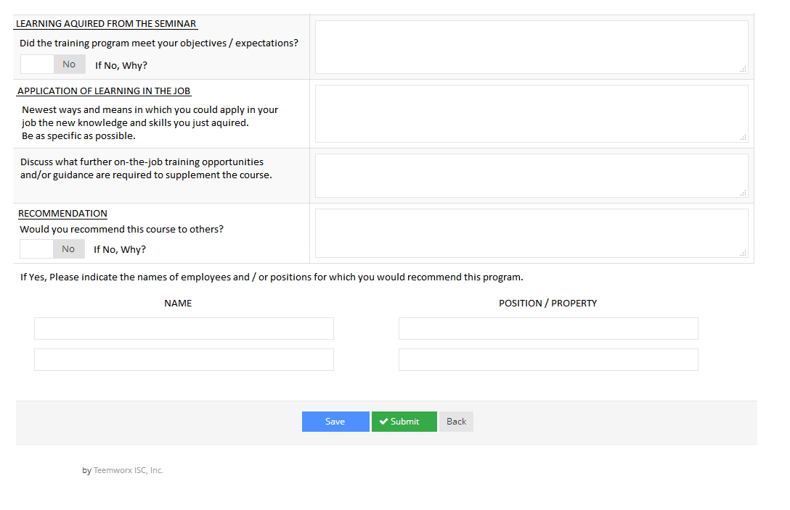

To complete the evaluation, click *Save* followed by *Submit* button

*Note: System and email notification will be sent to HR for the accomplished evaluation form*

**A1.11 –** RequestforExternal Training Printing

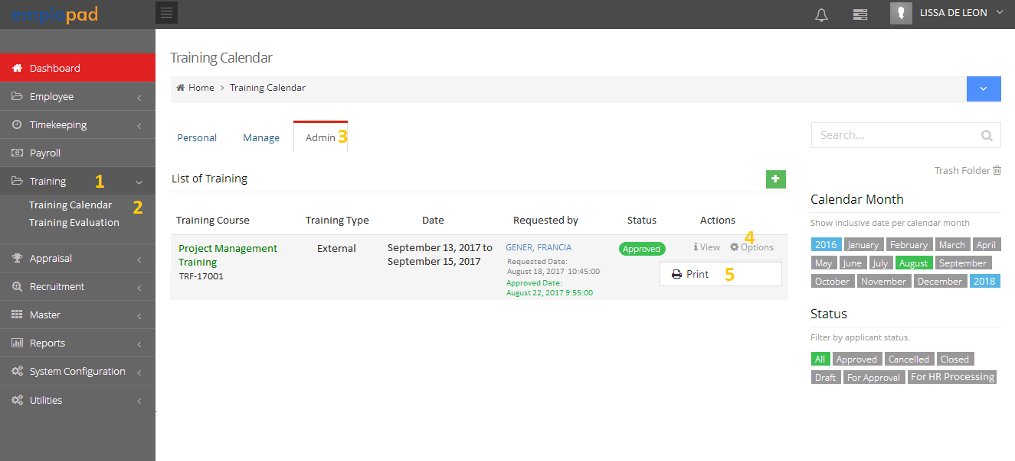

**A1.12 –** RequestforExternal Training Printout

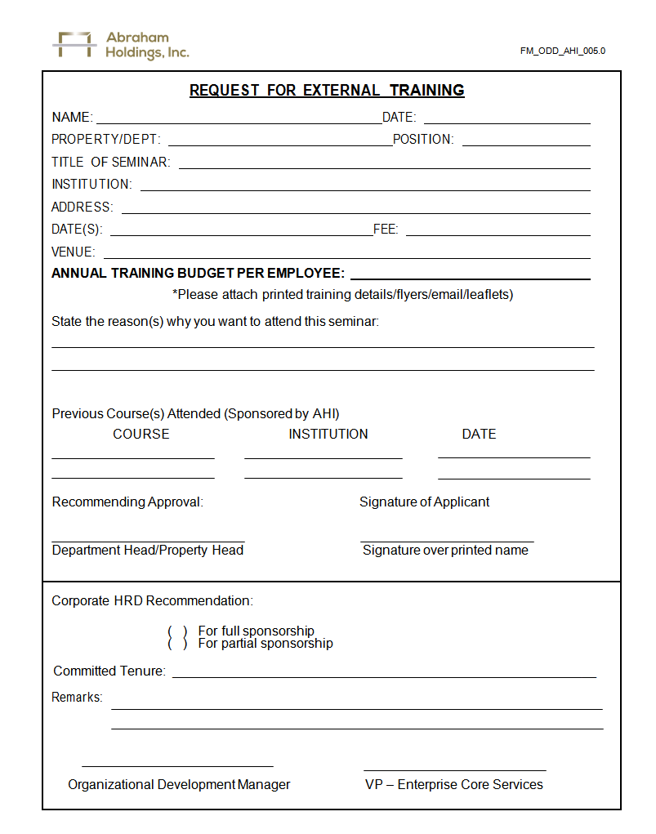

Captured from Training Objectives

Captured previous completed training (current year)

Captured from employee list with this positions

Add the control number

**A1.13 –** External Training Report Printing (HR)

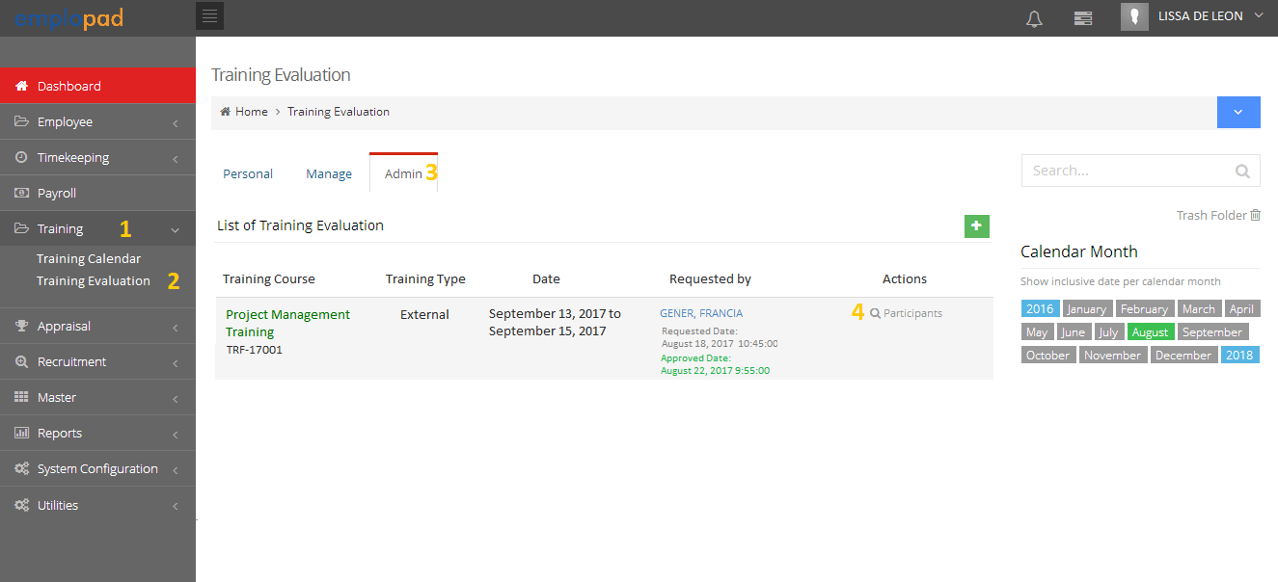

**A1.14 –** List of Participants

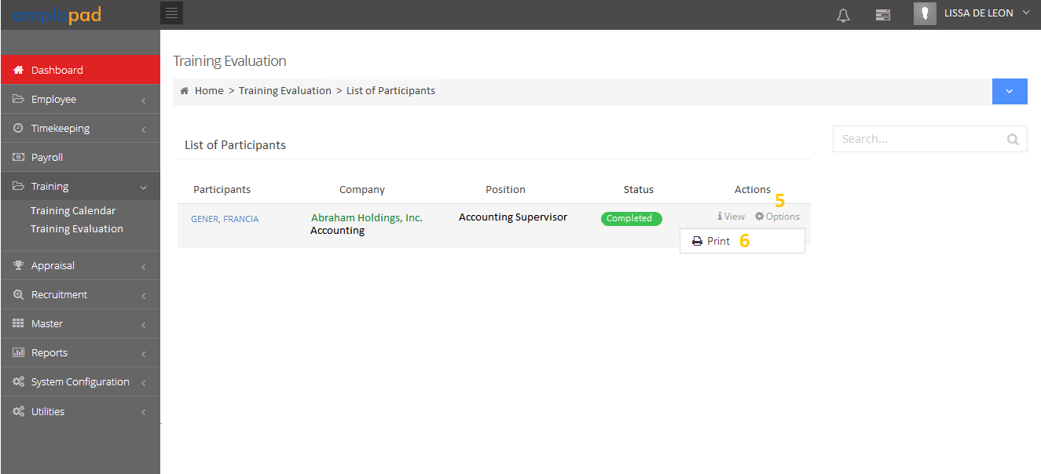

**A1.15 –** External Training Report Printout

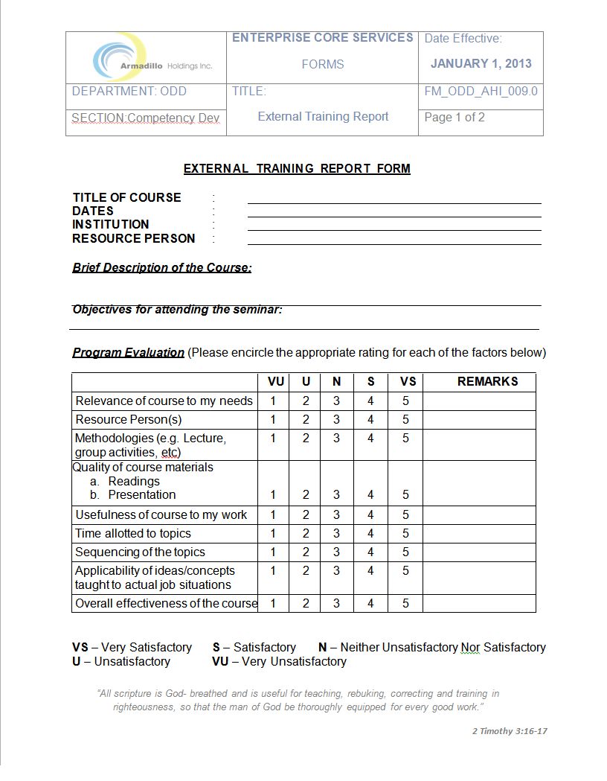

Remove

Remove the number and put bullet or check on the selected ratings

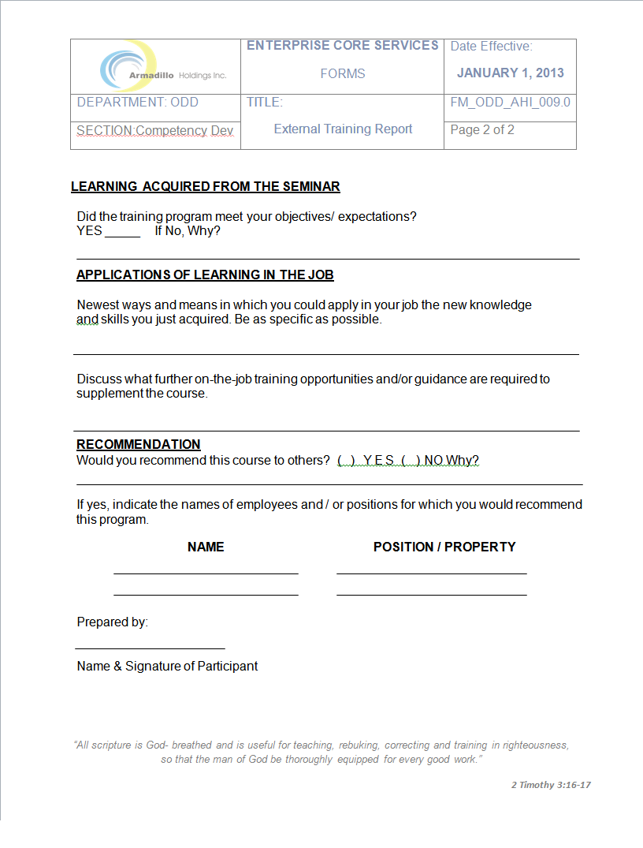

Replace with ( ) YES ( ) NO, Why?

then put bullet or check on the selected answer

Put bullet or check on the selected answer

1. **INTERNAL TRAINING**

**B1.01 –** HR will create internal training

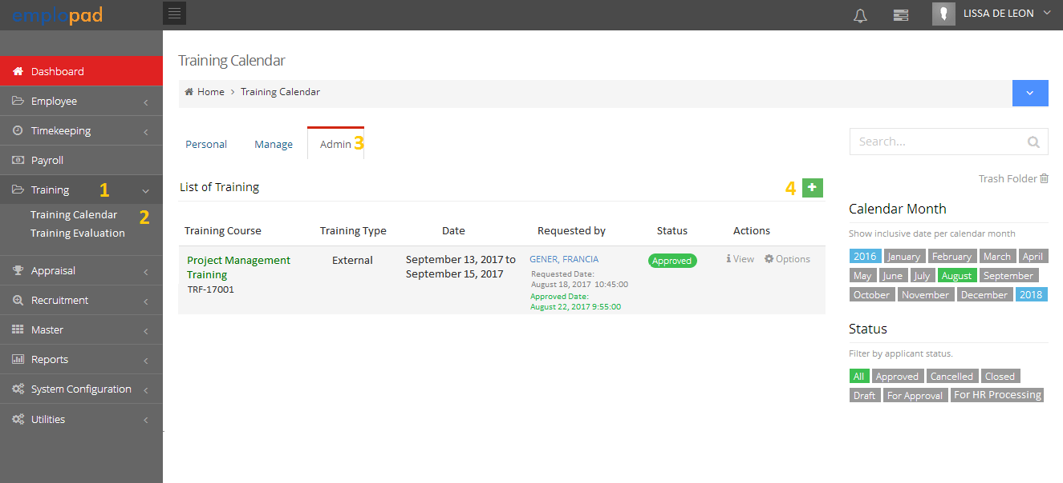

**B1.02 –** Training Form for fill-up by the HR.

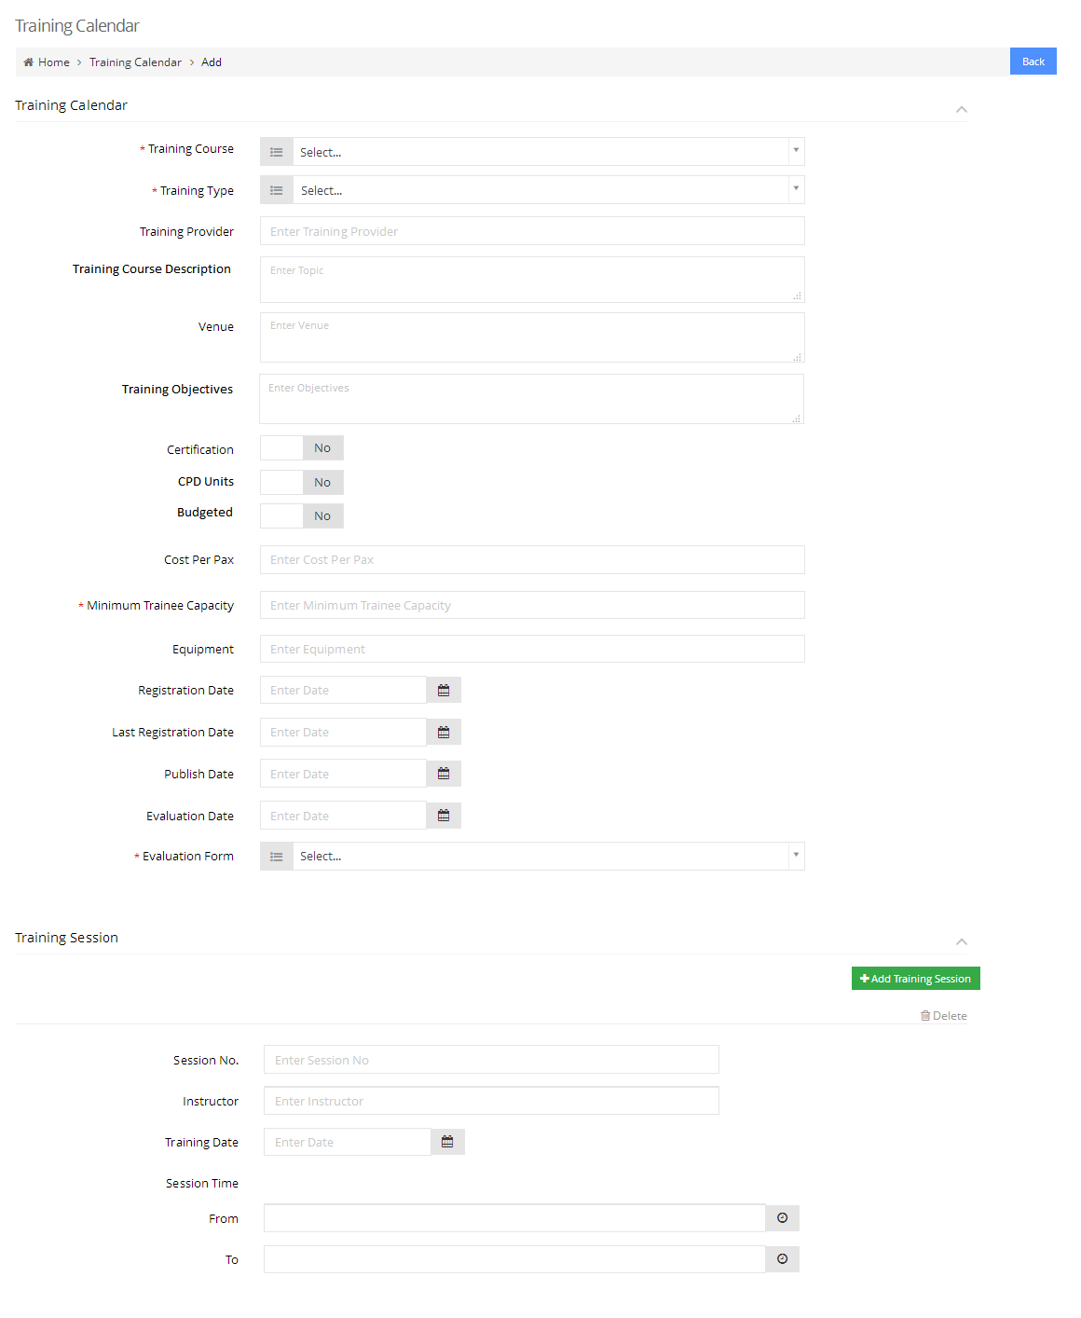

List of all training courses from the master

* Internal
* External

Option to breakdown details per session

* External Training Report Form
* Feedback Form

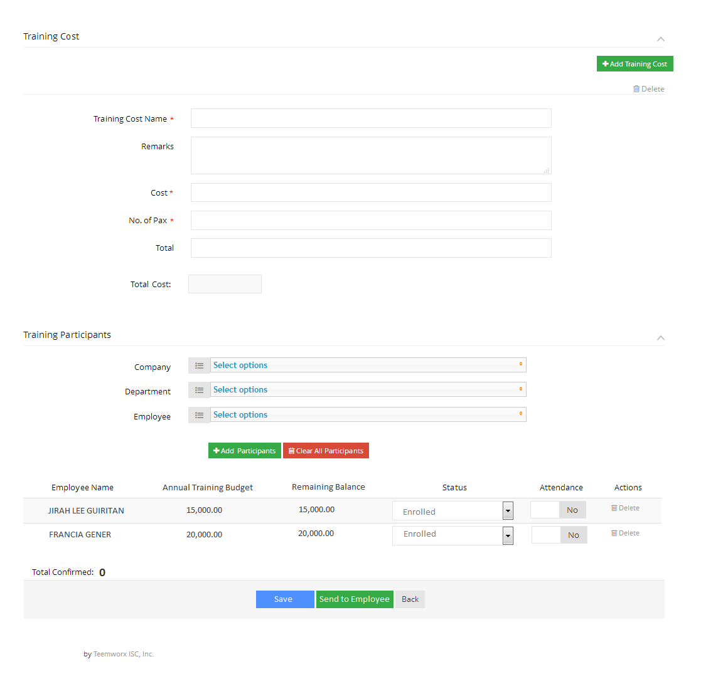

Option to breakdown details per training cost

Selection of participants can be filter by company and department

* Enrolled (default)
* Accept
* Declined
* List of added participants
* Auto display of annual training budget and remaining balances

Click *Send to Employee* button to complete the training invitation

*Note: System and email notification of training invitation will be sent to all participants*

**B1.03 –** Participant to accept of decline the training Invitation

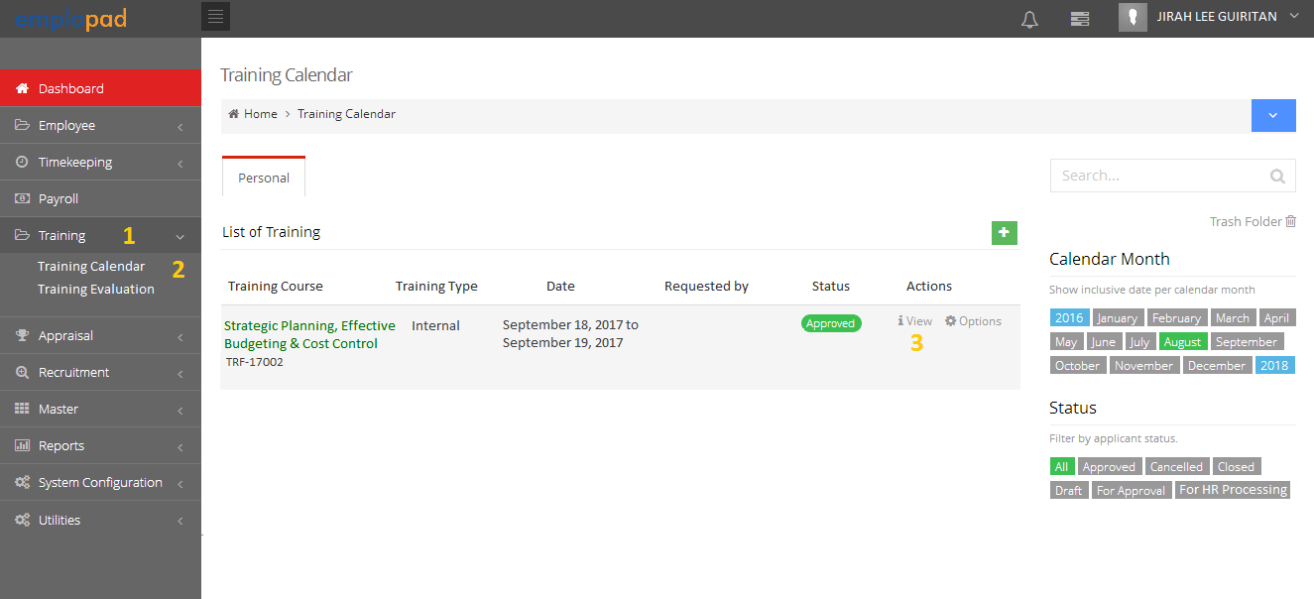

**B1.03 –** Training Invitation Form

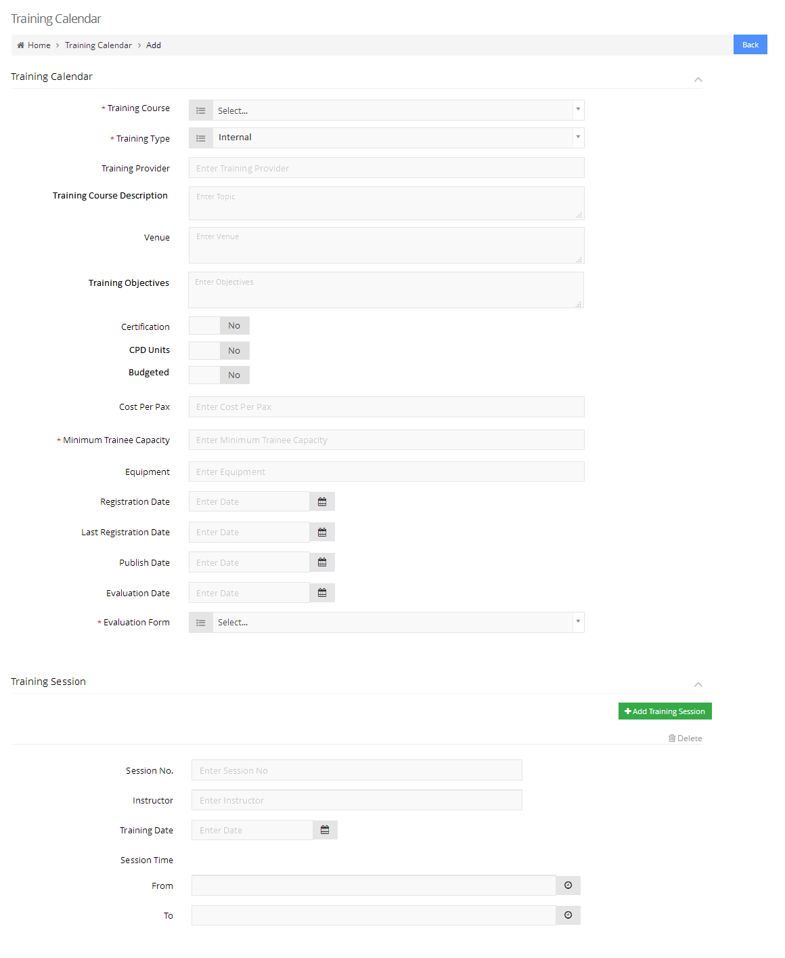

*Note: All fields are view only.*

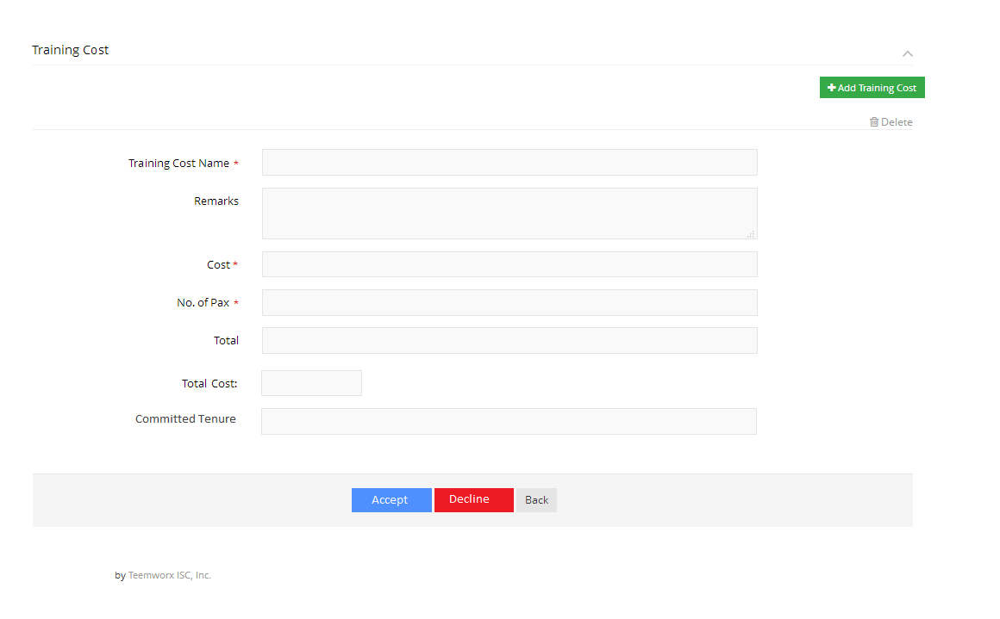

Click *Accept* button to confirm the participation on the training invitation

*Note:*

* *System and email notification of participant/s confirmation on the training will be sent to HR*
* *After the deadline of training invitation, HR will close the training form*

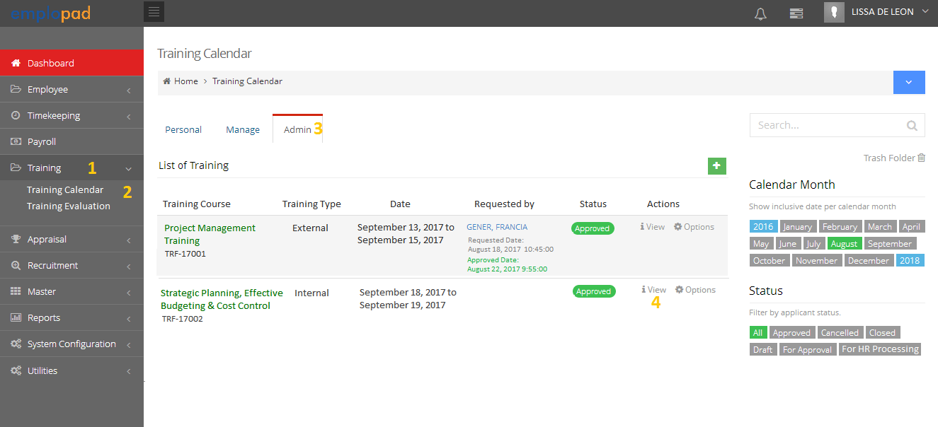**B1.04 –** Training Invitation Closing (HR)

**B1.05 –** Training Form Closing

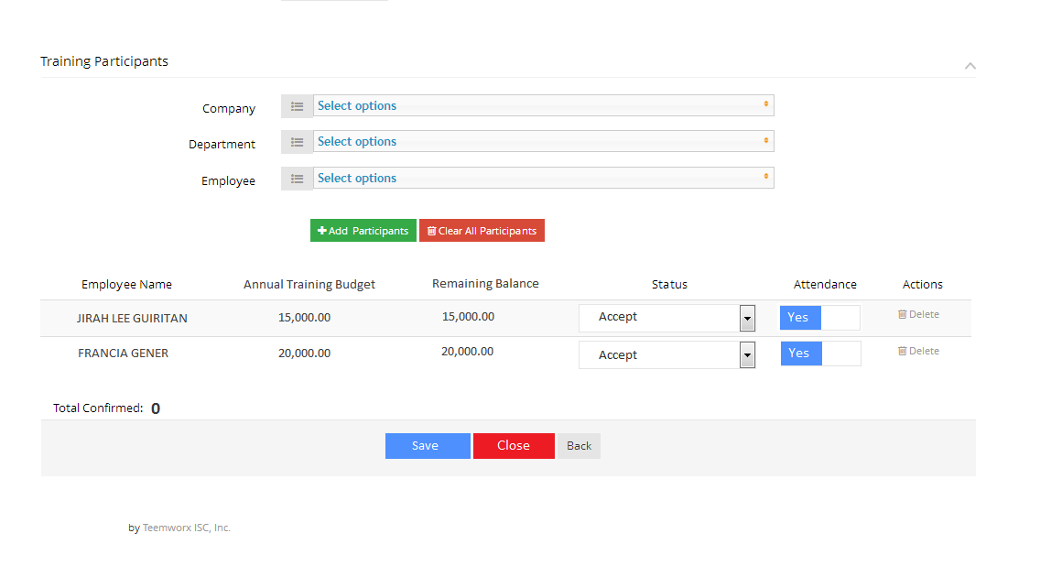

Set Attendance to *Yes* to all participants who attend the training then click *Save* followed by *Close* button

*Note: System and email notification will be sent to all participants to accomplish the training evaluation form*

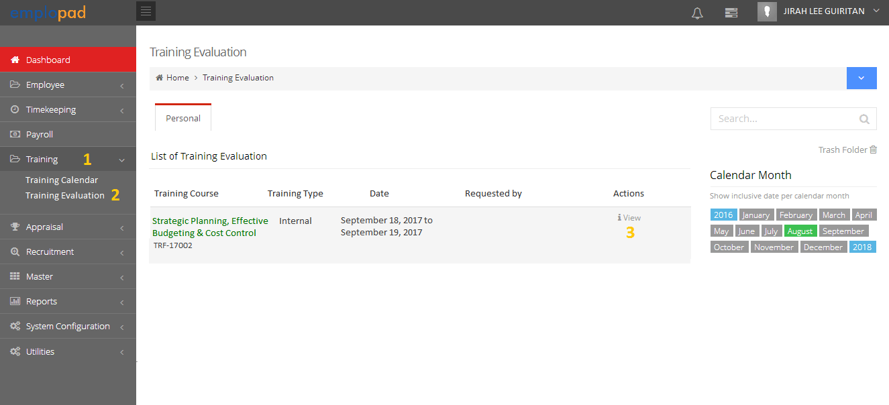**B1.06 –** Training Evaluation

**B1.07 –** Training Evaluation Form

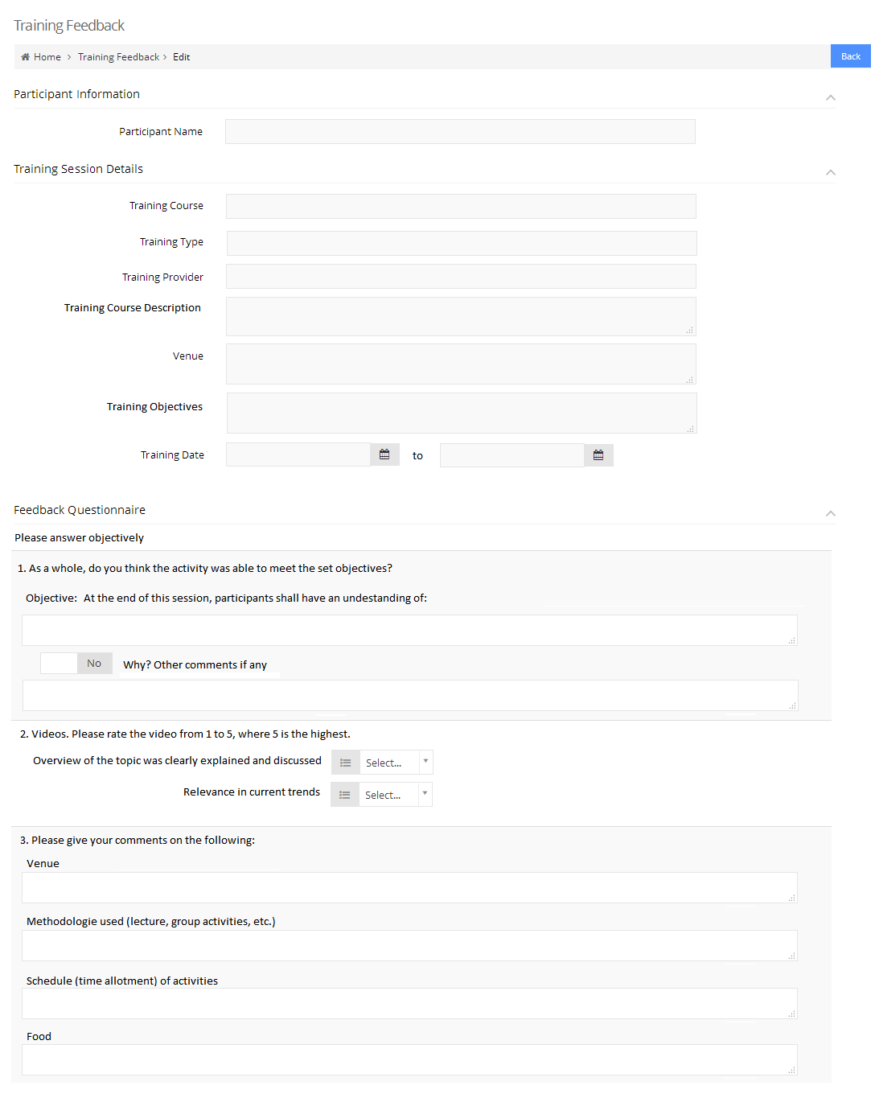

System to capture the information from the training invitation form

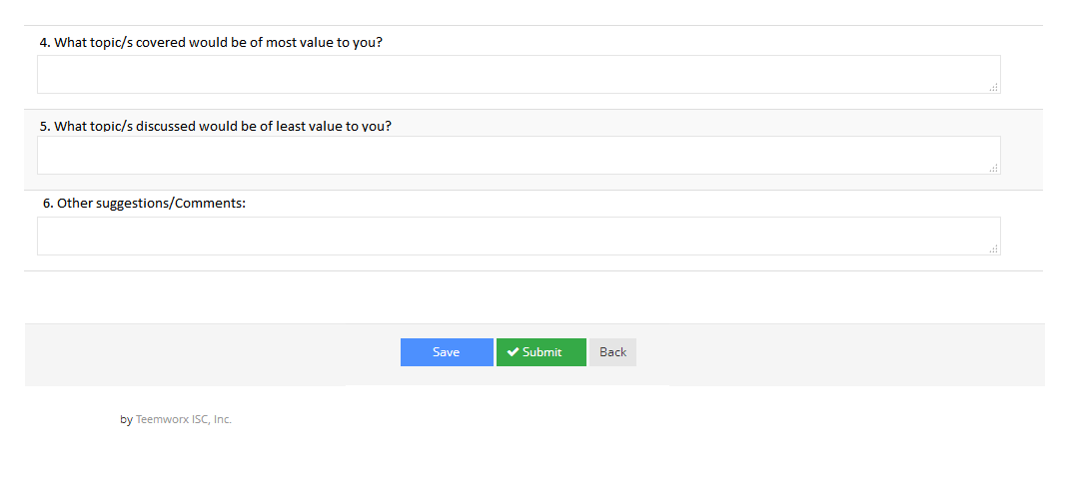

To complete the evaluation, click *Save* followed by *Submit* button

*Note: System and email notification will be sent to HR for the accomplished evaluation form*

**B1.08 –** Internal Training Feedback Form Printing

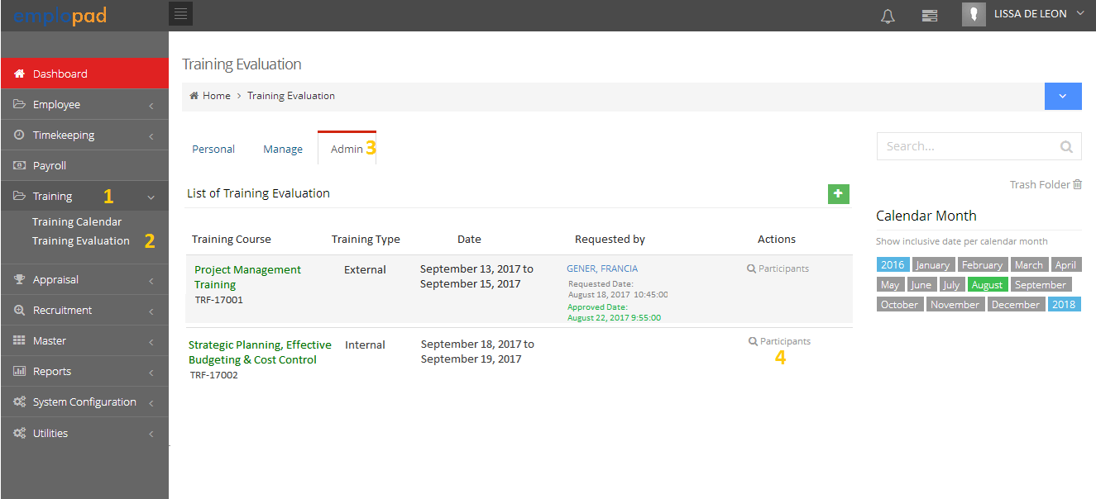

**B1.08 –** List of Participants

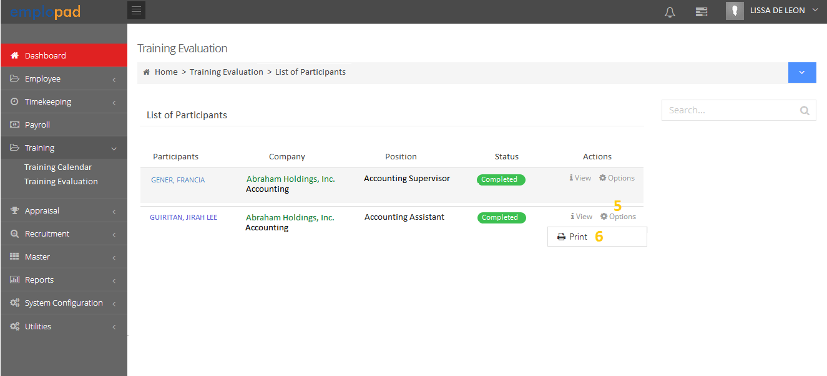

**B1.10 –** Feedback Form Printout

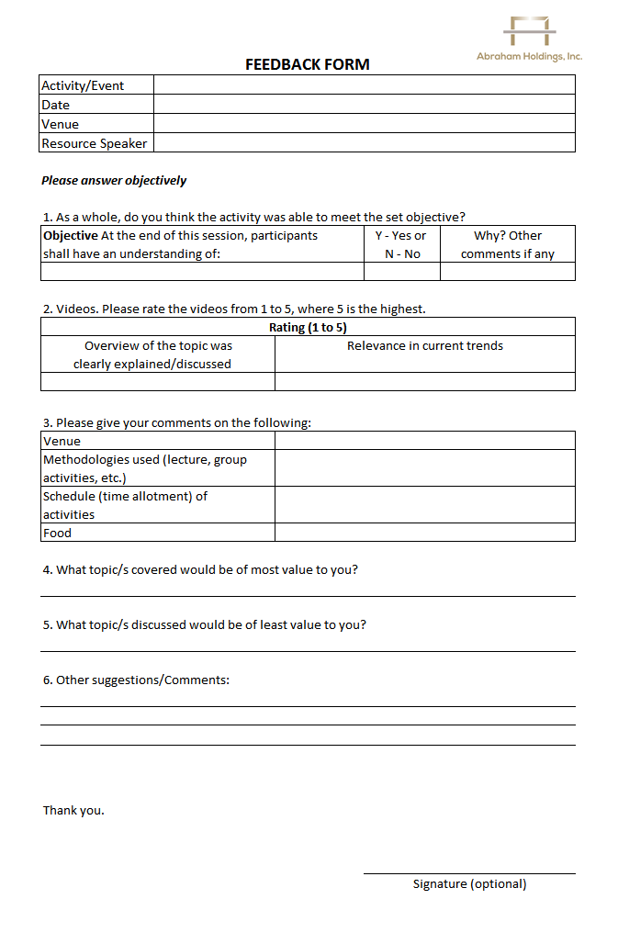

Do not print the participant’s name